**For Immediate Release**

**Clinical Canine Massage Significantly Reduces Pain Severity in Dogs, Study by University of Winchester Finds**

[***Now published in Vet Record***](https://bvajournals.onlinelibrary.wiley.com/doi/10.1002/vetr.586)

9th March 2022

The findings from the first ever large-scale study into the efficacy of clinical canine massage on the treatment of pain have been published in Vet Record, the official journal of the British Veterinary Association (BVA).   The study, a collaboration between the Canine Massage Guild and the University of Winchester, is the first of its kind to produce clinically verifiable evidence from a cohort of 527 cases.

Dr Lisa Riley, Lecturer in Animal Welfare, comments, “To our knowledge, this is the most comprehensive quantitative analysis of the effects of canine massage therapy to date globally. By reviewing owner- and practitioner-rated pain severity scores we have shown that, in our sample of dogs, pain severity significantly reduced after just one massage therapy session and continued to significantly reduce with each subsequent treatment.

“Collectively dog pain severity went from ‘moderate’ to ‘mild’. Importantly, practitioners considered the dogs’ quality of life improves following treatment. This study suggests massage therapy may be a meaningful inclusion in a musculoskeletal pain management plan.

Dr. Riley concludes, “Working with the Canine Massage Guild has been such a positive experience. The knowledge and commitment of the practitioners, and their help and support with this study has been invaluable. I look forward to organising the forthcoming blind clinical trial with the Guild.“

**The Methodology**

With veterinary consent, Canine Massage Guild practitioners employed the Lenton Method® to treat muscular and myofascial conditions in dogs of all ages and across many breeds.  The study looked at whether massage positively affected the quality of life of dogs experiencing chronic pain, lameness, signs of ageing, athletic performance and subclinical signs of pain as reported by owners.

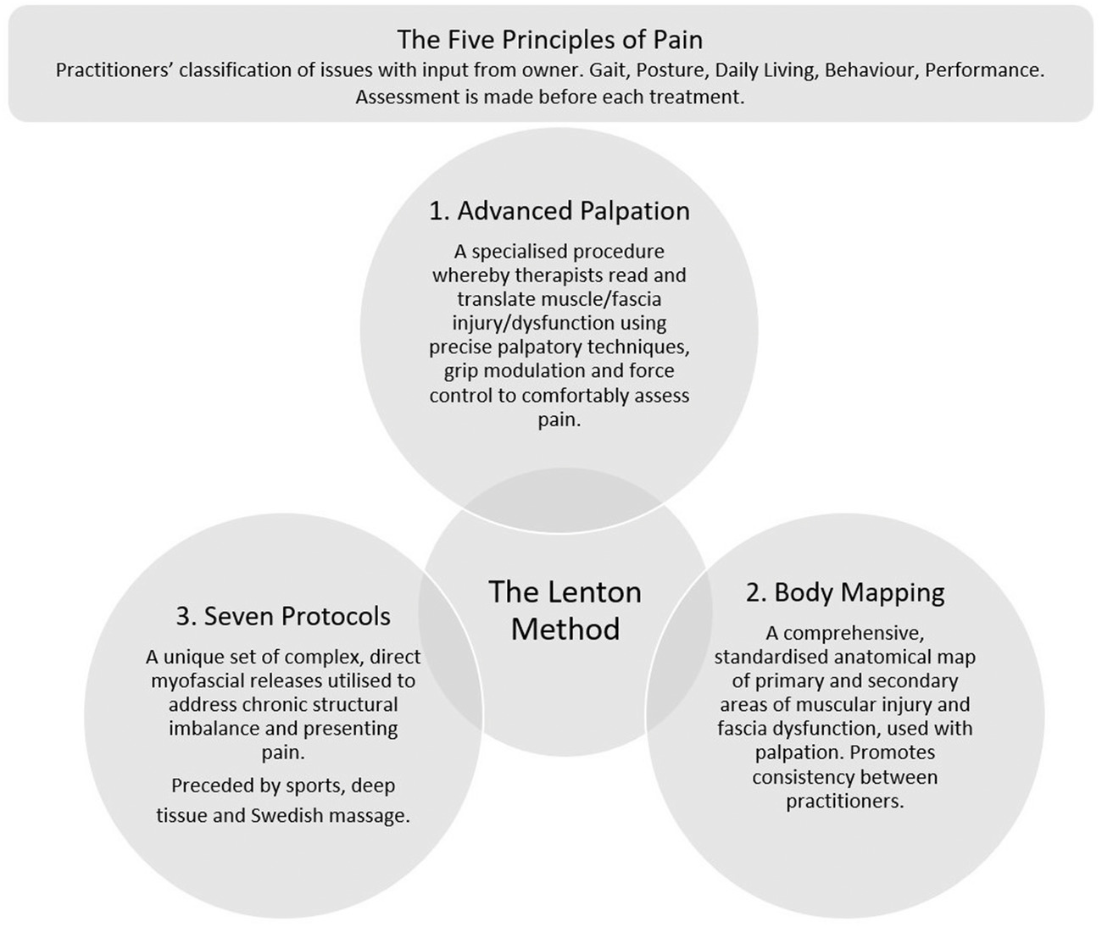

(See infographic, The Lenton Method)

The practitioners were asked to complete a standardised report per dog documenting life history variables (e.g., age, breed, sex), clinical diagnoses and known or deduced aetiologies, and number, severity (score) and improvement status (improved/worsened/no change) of each of 5 principles of pain parameters (gait, posture, ADLs, behaviour, performance) prior to massage therapy and again after a course of three, hour-long massages.  Finally, in consultation with the subject’s owner, the practitioner considered post-treatment results and these data were submitted to the University from across the UK, Ireland, and Spain.

**Results**

Out of 527 dogs, 492 dogs responded to treatment. The variables between cases such as age, breed and conditions were of a diverse enough range to ensure the type of dogs that therapists see in practice were represented. Whilst there are many reasons for whether or not a dog is responsive, this result evidenced that veterinary-diagnosed musculoskeletal conditions responded successfully after clinical canine massage therapy.  Positive changes in the dogs’ mobility and behaviours were often observed after just one treatment, increasing with subsequent sessions.

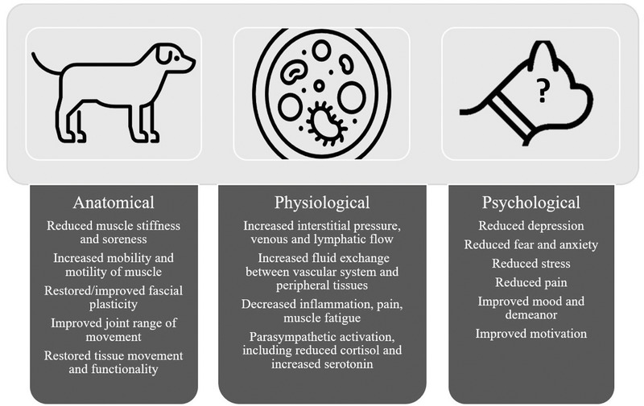

(Image: Potential therapeutic massage benefits in dogs (after Corti, 2014).)

This study is part of a wider suite of studies with the gold standard of double-blind trials already planned with the Canine Massage Guild and Winchester University in the future.

Canine Massage Guild Chair Natalie Lenton says, “To date, the success and popularity of clinical canine massage therapy has been the result of word-of-mouth recommendations and the hard work of individual therapists.  Studies such as this will be responsible for not only the stellar growth of our industry but the growth of animal complementary therapies as a whole.

“Publication in Vet Record indicates that the veterinary profession acknowledges the important role of complementary therapies as part of a vet-led, multimodal team and signifies real progression for canine complementary therapists all over the globe.

Natalie concludes, “I would like to thank the hundreds of owners who have entrusted their dog's care to Guild practitioners and participated in this pioneering collaborative study between the Canine Massage Guild, Canine Massage Therapy Centre, and Winchester University. The improvements seen by owners after treatment employing the Lenton Method® has led to a significant growth in the number of dogs benefiting from this safe and non-invasive therapy. As an organisation committed to evidence-based practice, I believe that the findings of this study will further increase confidence in our unique clinical canine massage methodology."

In order to help veterinary practices meet the demand for clinical canine massage from one of our 150+ therapists using the Lenton Method®, we have created an educational leaflet that takes a deep dive into our code, ethics and methodology.  It is available to download here [Integrated Veterinary Care Initiative](https://www.k9-massageguild.co.uk/veterinary-information-zone/).

-oOo-

**About the Canine Massage Guild**

Clinical Canine Massage Therapy is unique to members of the Canine Massage Guild and typically sees results in 1-3 sessions based on an ethical client approach model and the unique integrative blend of 4 disciplines of massage alongside the exclusive Lenton Method®.

For chronic pain management, soft tissue injury rehabilitation, and orthopaedic and neurological condition support, clinical canine massage blends myofascial release, both the direct and indirect approach, sports massage, deep tissue massage and Swedish massage as well as the trademarked MFR protocols from the Lenton Method™, a three-pronged approach that incorporates advanced palpation skills, BodyMapping (an actual map of the body that is used to determine common areas of muscular injury and issue as well as myofascial pain developed over the course of 10 years) and ‘The 7 Protocols’, a unique set of myofascial release techniques that produce long lasting results.

Clinical therapists are also trained in the assessment of orthopaedic and neurological conditions essential for patient referral back to their consenting vet to ensure paramount client care. Written reports are also provided to the consenting vet and sensible home care plans are provided to the owner.

The initial Clinical Canine Massage Practitioner Programme is delivered by the Canine Massage Therapy Centre Ltd.  over a period of 2 years and it is externally accredited by LANTRA. Upon completion and pass of written and practical examinations therapists are able to join the Canine Massage Guild and commit to Continuing Professional Development  (25 hour/year minimum) provided exclusively by CMTC for Guild members including manual lymphatic drainage, facilitated stretching, skill reviews, neuromuscular refacilitation, ventral MFR and other clinically appropriate bodywork courses.

Animal welfare, consumer protection, clarity of law and professional standards are the Guild’s core values alongside providing the best service possible to dogs, their owners and vets. The online therapist register includes members from the UK, Ireland, and Spain.

For further information:

Natalie Lenton

Tel. 07877 540728

Email: [info@k9-massage.co.uk](mailto:info@k9-massage.co.uk)

Web: [www.K9MassageGuild.co.uk](http://www.k9massageguild.co.uk/)